MODULE 4 – INTRODUCTION TO DBMS

LAB EXERCISES

1.1 Introduction to SQL
Create a new database named school_db and a table called students with the following columns – student_id, student_name, age, class and address.
Ans.
Create a database names school_db
1. CREATE DATABASE school_db
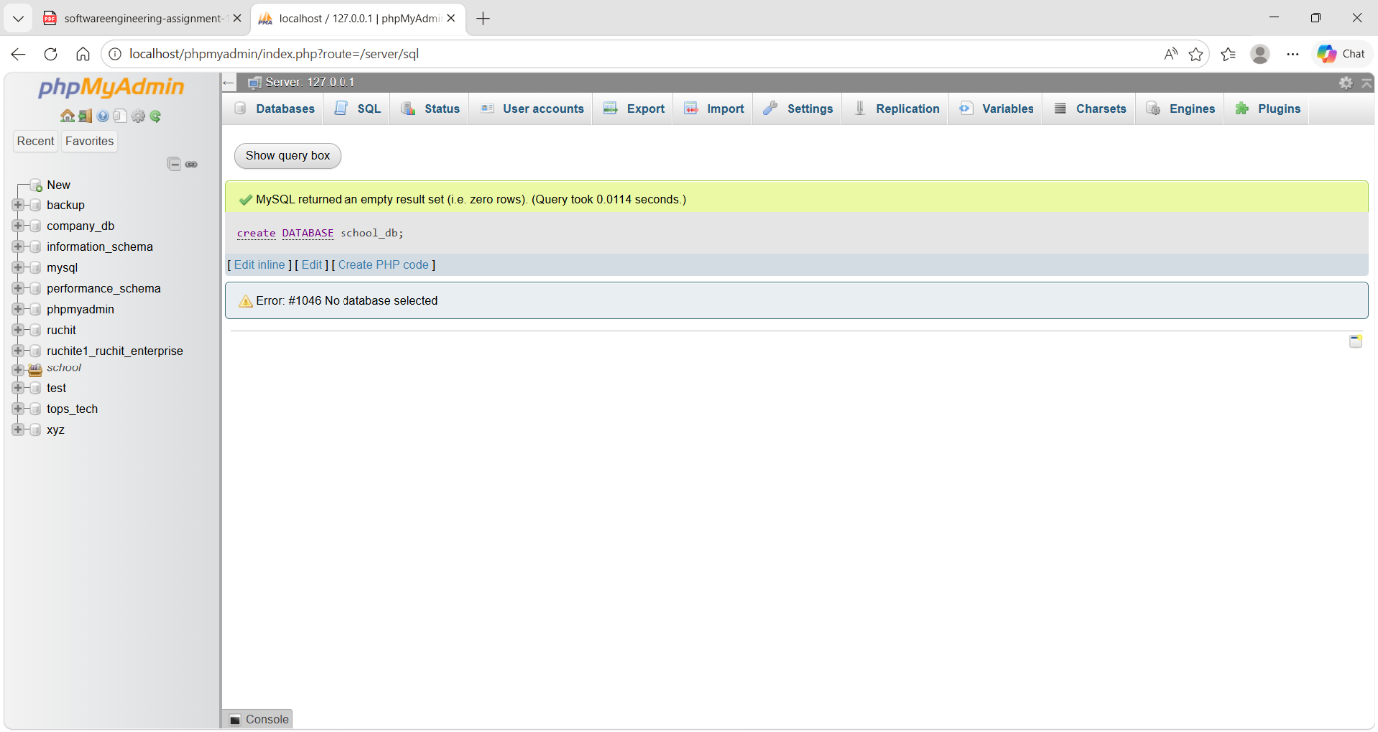

2. CREATE TABLE student(student_id int PRIMARY KEY AUTO_INCREMENT, student_name varchar(255), age int, class varchar(255), address varchar(255))
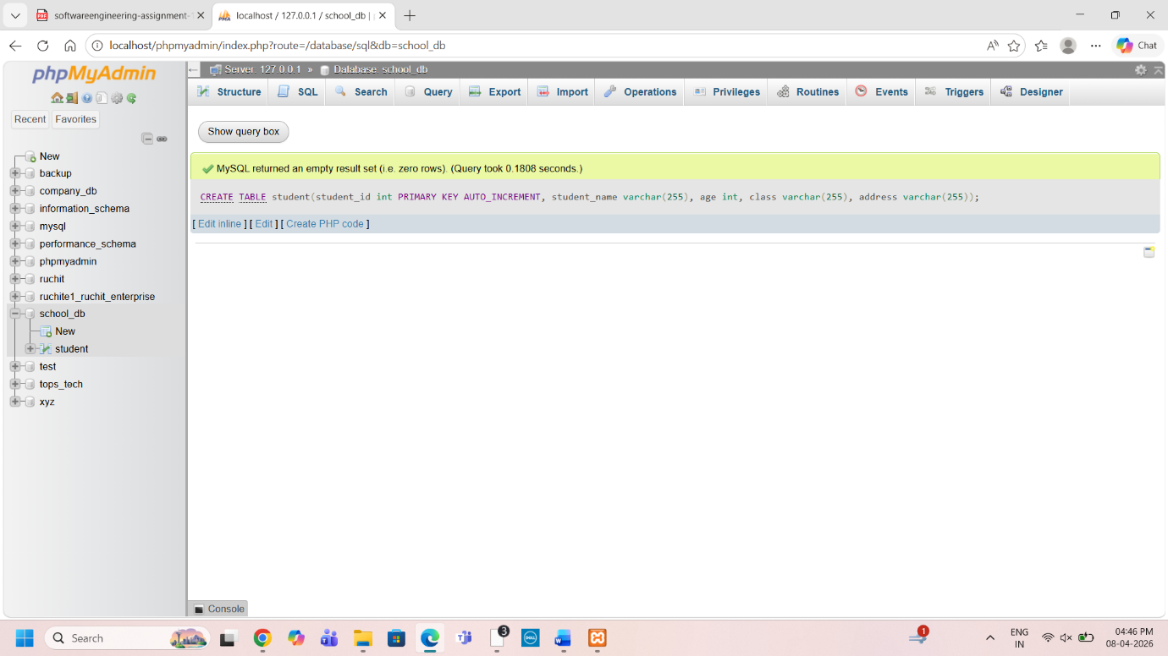
1.2)Insert five records into the students table and retrieve all records using the SELECT statement.
Ans.
1. INSERT INTO student(student_name, age, class, address) VALUES ('rajvi', '20', ‘12’, 'rajkot’),
('Purvi', '15', '8th', 'Baktinagar'), ('Vaibhav', '17', '12th', 'Champaknagar'), ('Jatin', '22', 'Graduate', 'Railnagar'), ('Himshikha', '25', 'Graduate', 'Kalawad road');
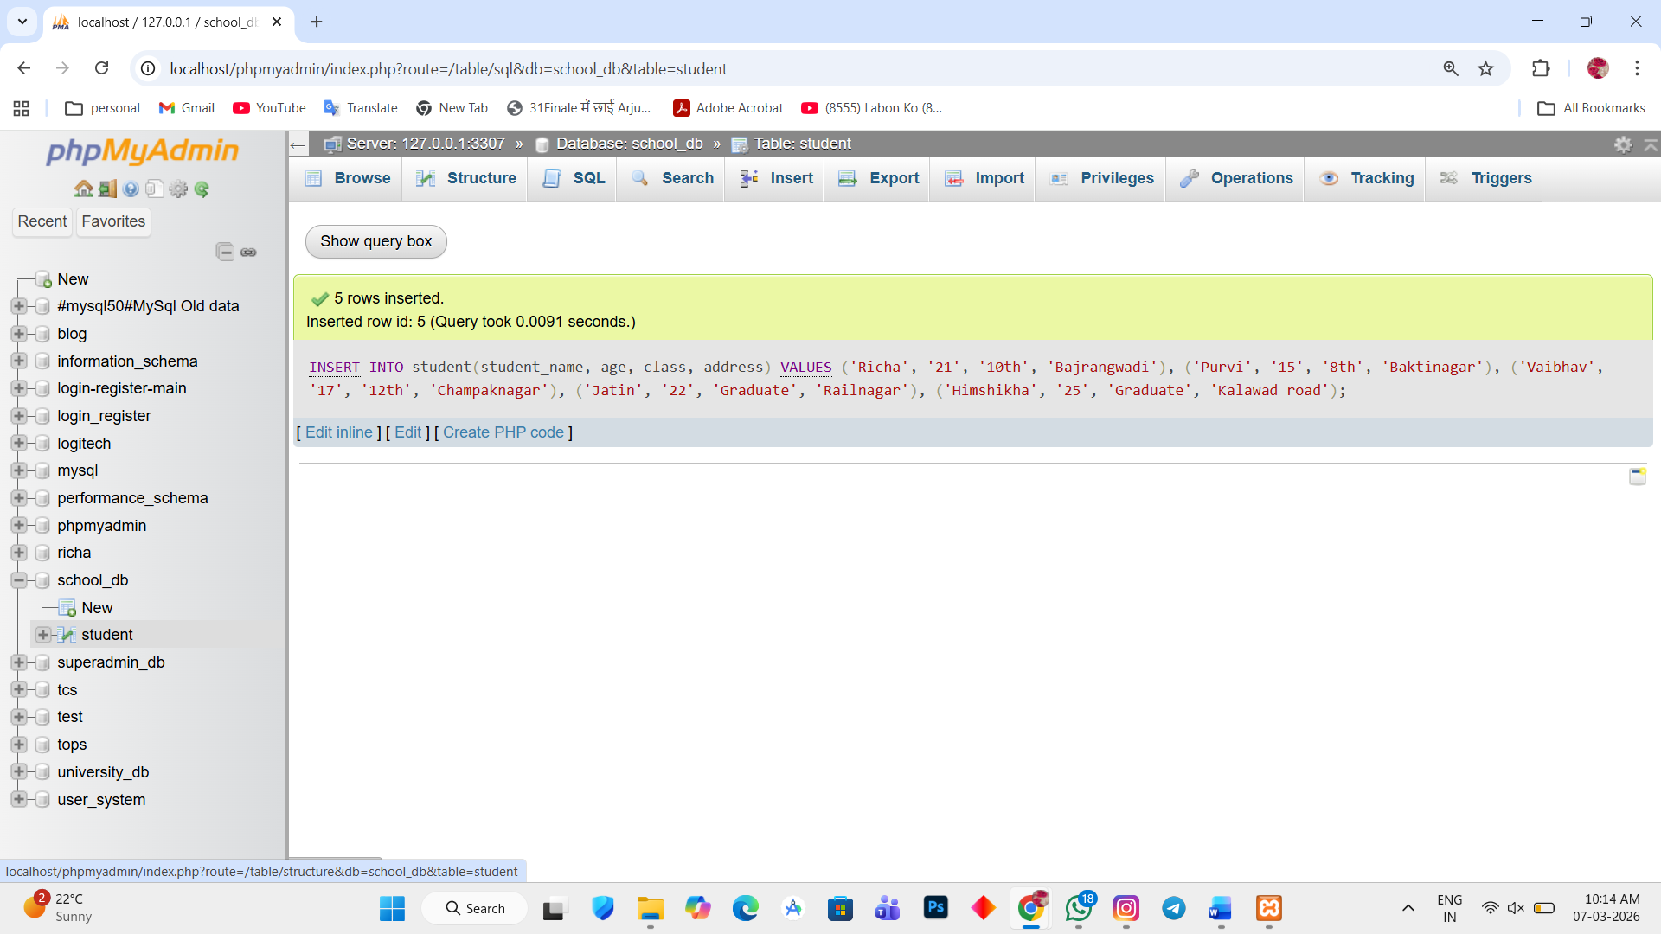
2. SELECT * FROM `student`
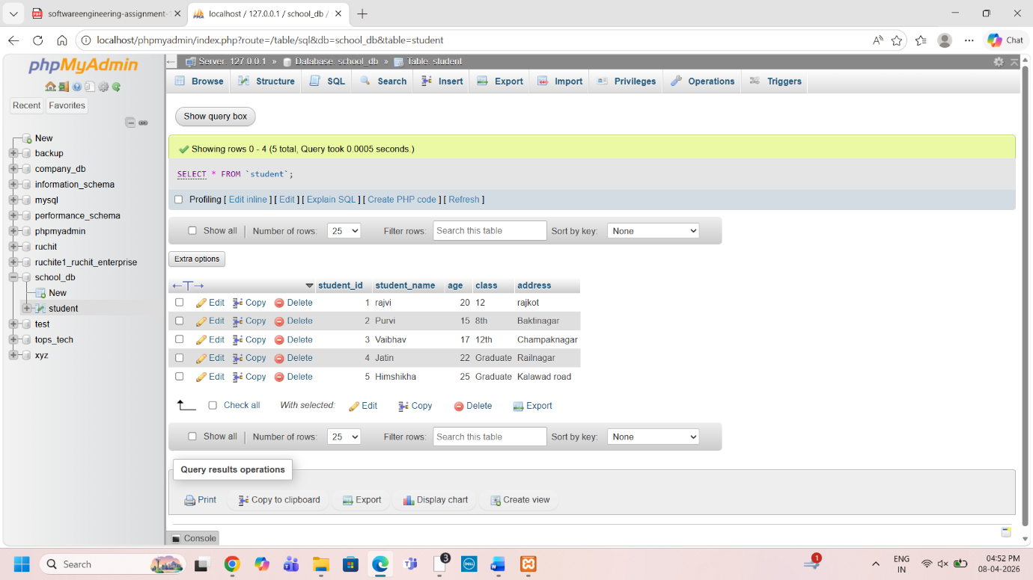
2.1) Write SQL querie to retrieve specific columns (student_name and age) from the students table
SELECT student_name ,age FROM `student`
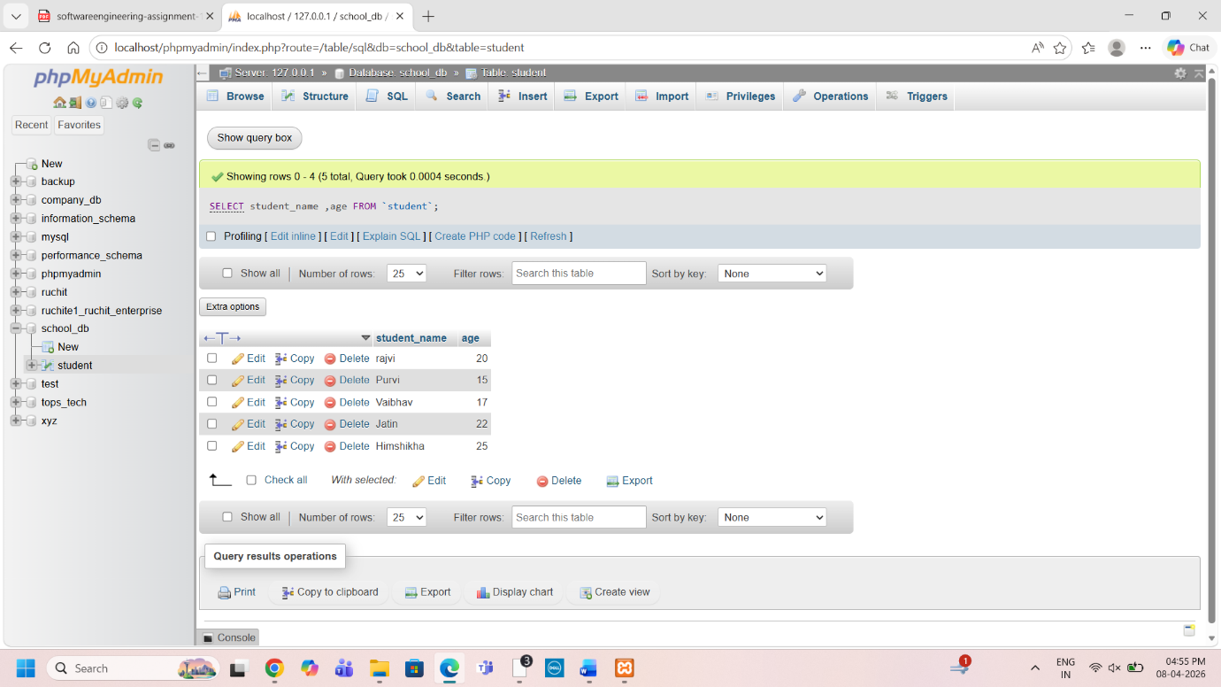

2.2) : Write SQL queries to retrieve all students whose age is greater than 10
SELECT student_name,age FROM `student` WHERE age>10
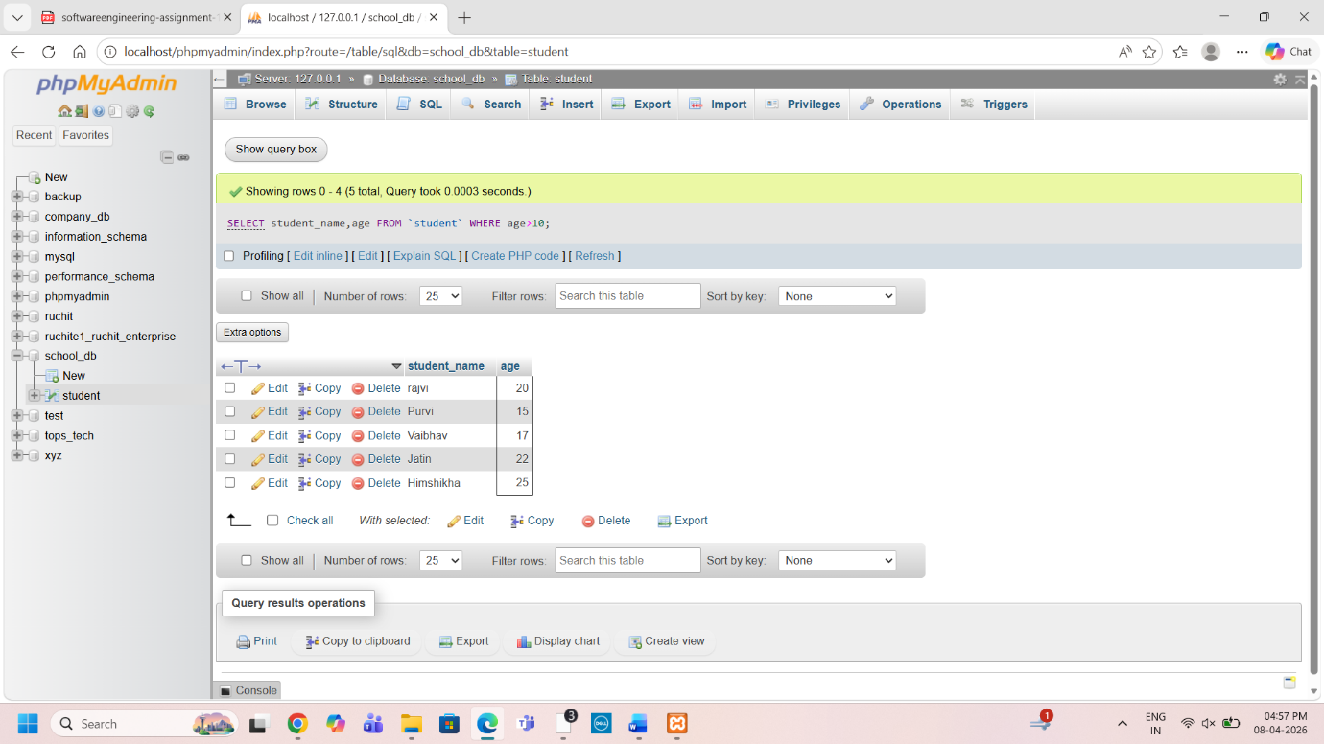

3.1) Create a table teachers with the following columns:teacher_id (PrimaryKey), teacher_name(NOTNULL), subject(NOTNULL), and email (UNIQUE).
CREATE TABLE teachers (
teacher_id INT PRIMARY KEY,
teacher_name VARCHAR(100) NOT NULL,
subject VARCHAR(100) NOT NULL,
email VARCHAR(100) UNIQUE
);
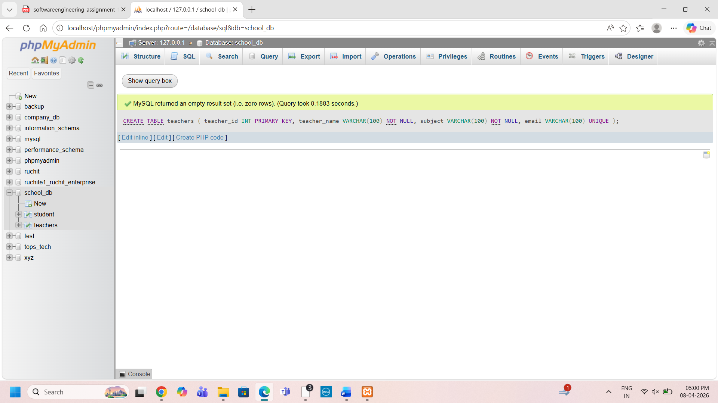
3.2) Implement a FOREIGN KEY constraint to relate the teacher_id from the teachers table with the students table.

4.1)Create a table courses with columns:course_id,course_name,and
course_credits.Set the course_id as the primarykey.
create table courses (course_id int PRIMARY key AUTO_INCREMENT,course_name varchar(255),course_credits double)
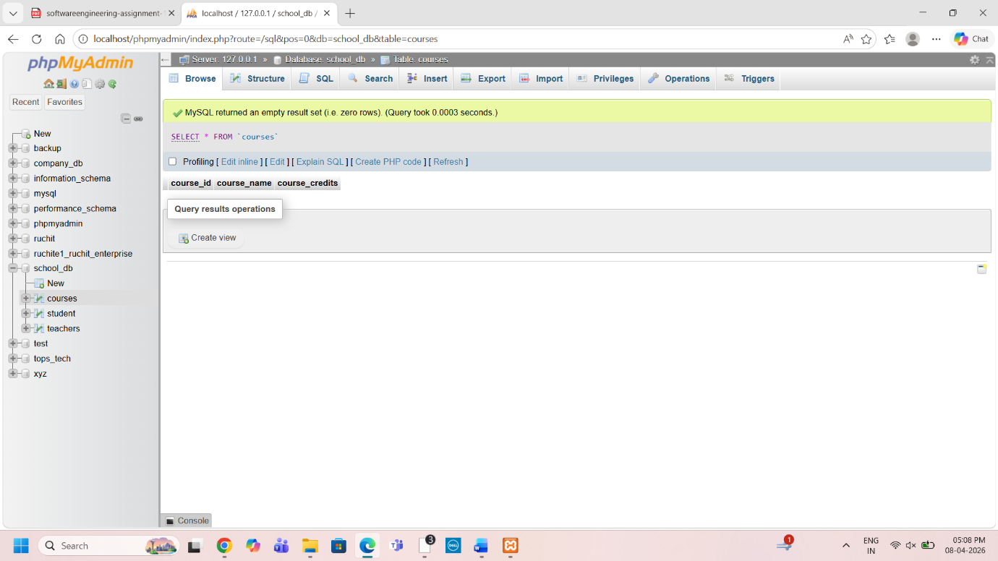

4.2) Use the CREATE command to create a database university_db
Create database university_db
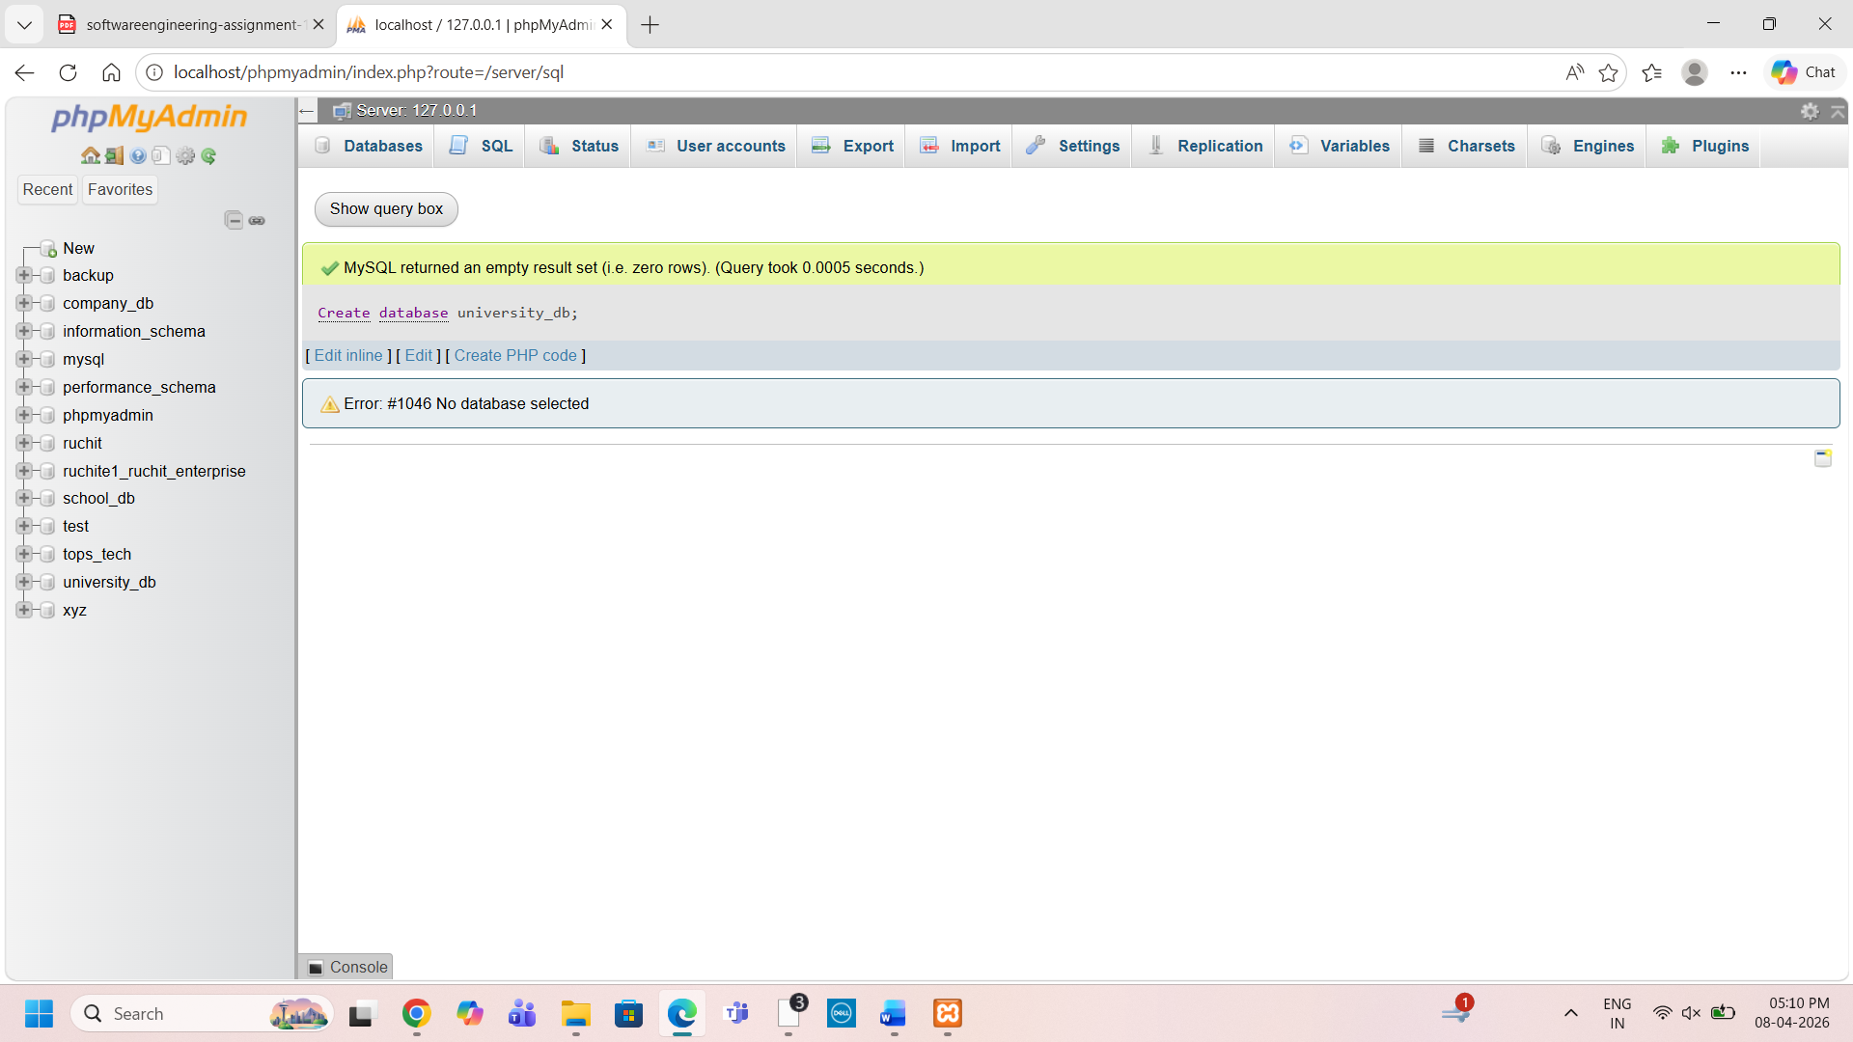
5.1) Modify the courses table by adding a column course_duration using the ALTER command.
alter table courses add course_duration double;
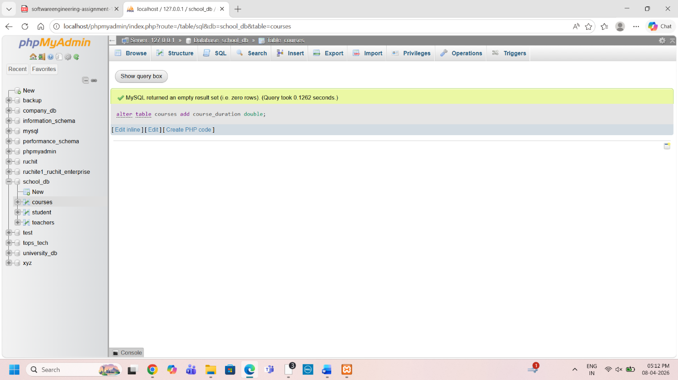
5.2) Drop the course_credits column from the courses table
alter table courses drop course_credits;
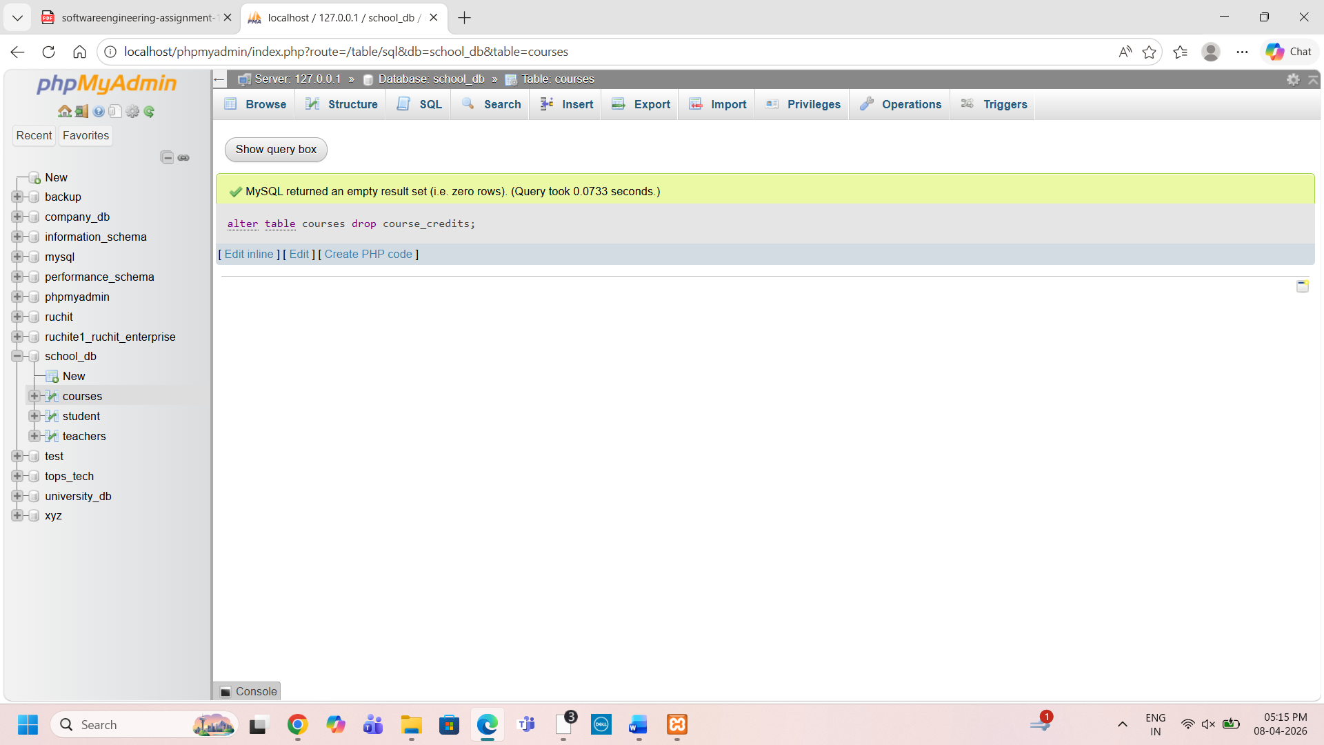

6.1) Drop the teachers table from the school_db database
drop table teachers
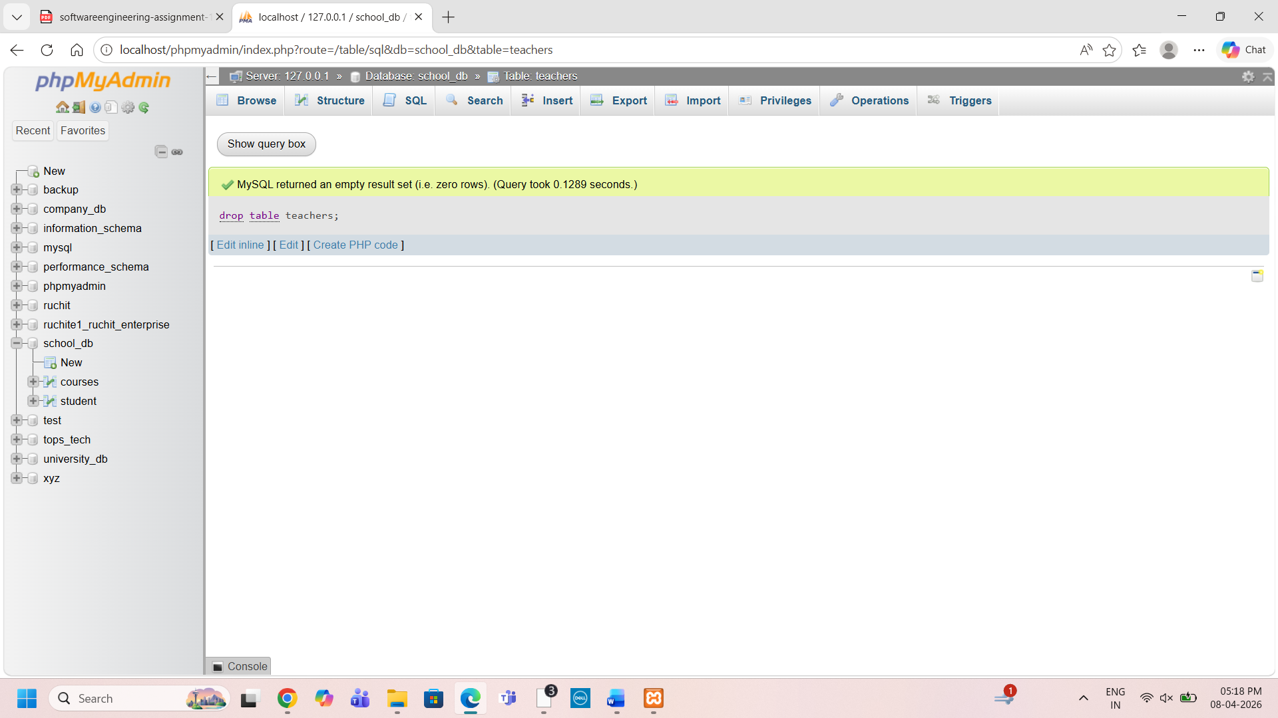

6.2)Drop the students table from the school_db database and verify that the table has been removed.
drop table student
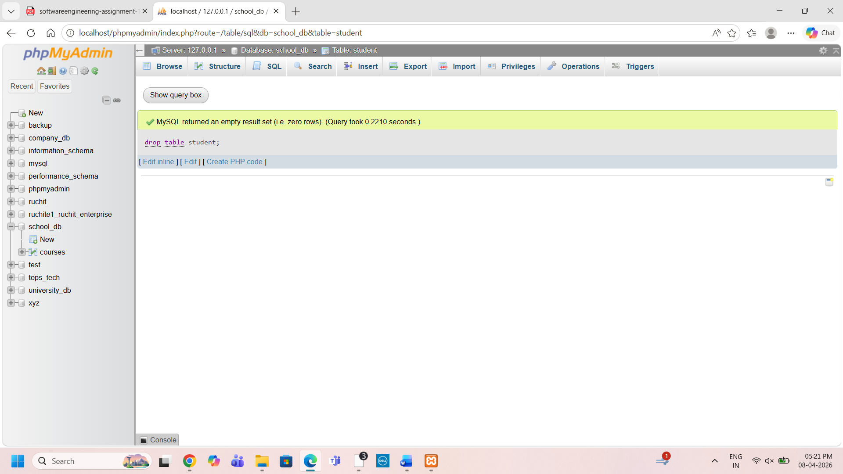
Verifying:
Show tables
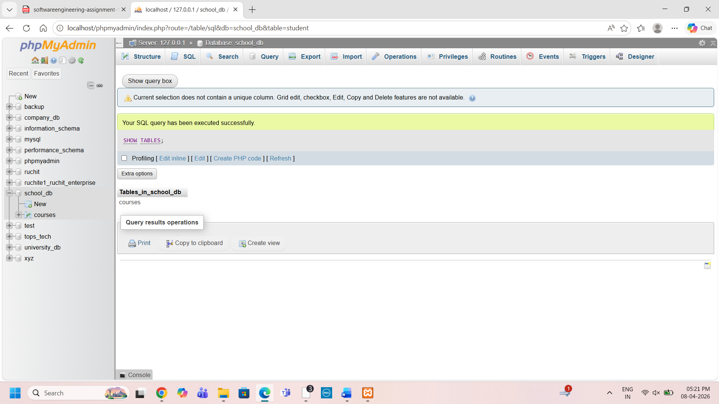
7.1) Insert three records into the courses table using the INSERT command
INSERT into courses (course_name,course_duration) values ('python',2),('java',3),('flutter',4);
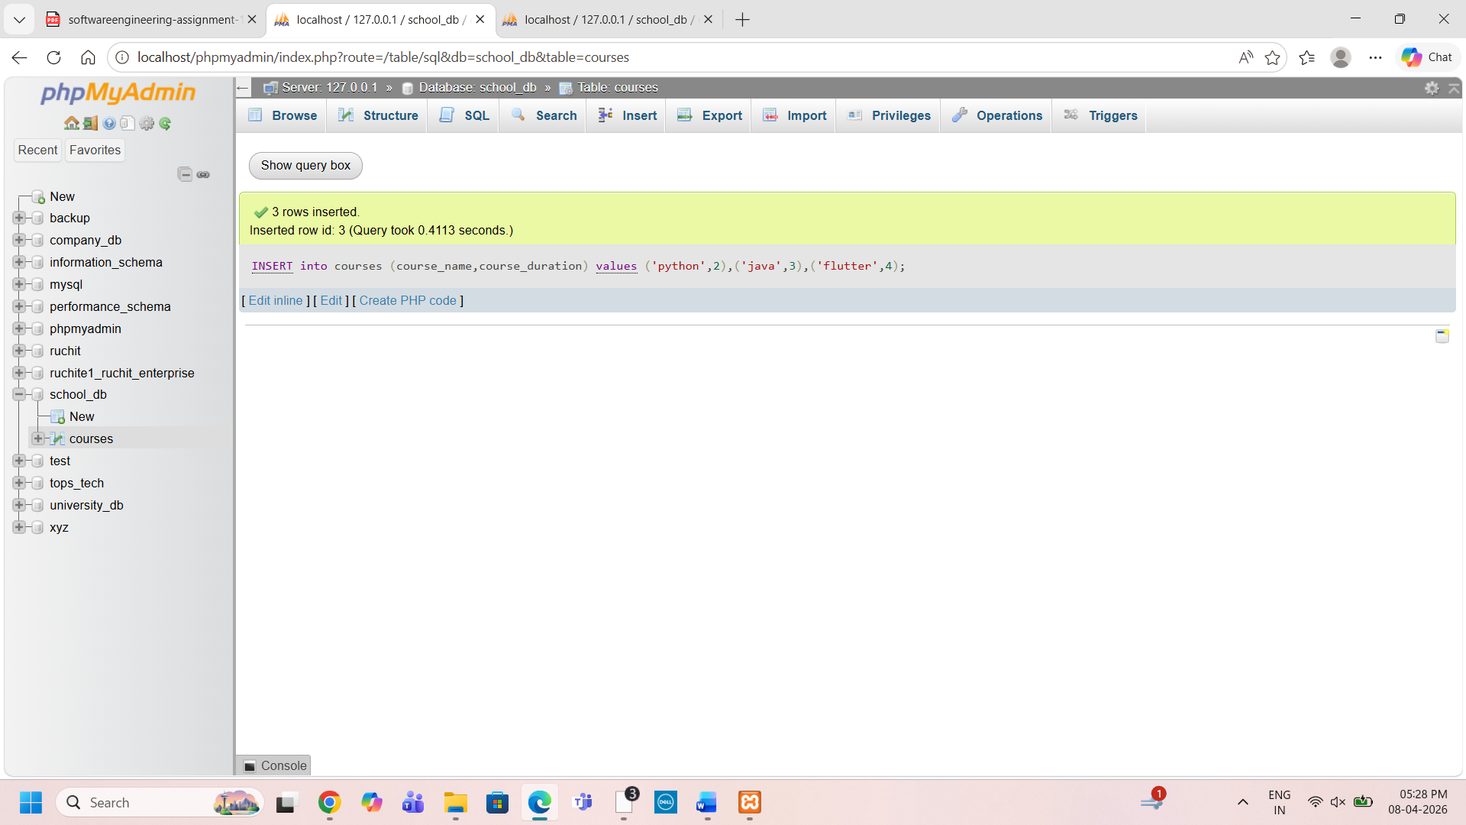
7.2) Update the course duration of a specific course using the UPDATE command.
update courses set course_duration=10 where course_name='java'
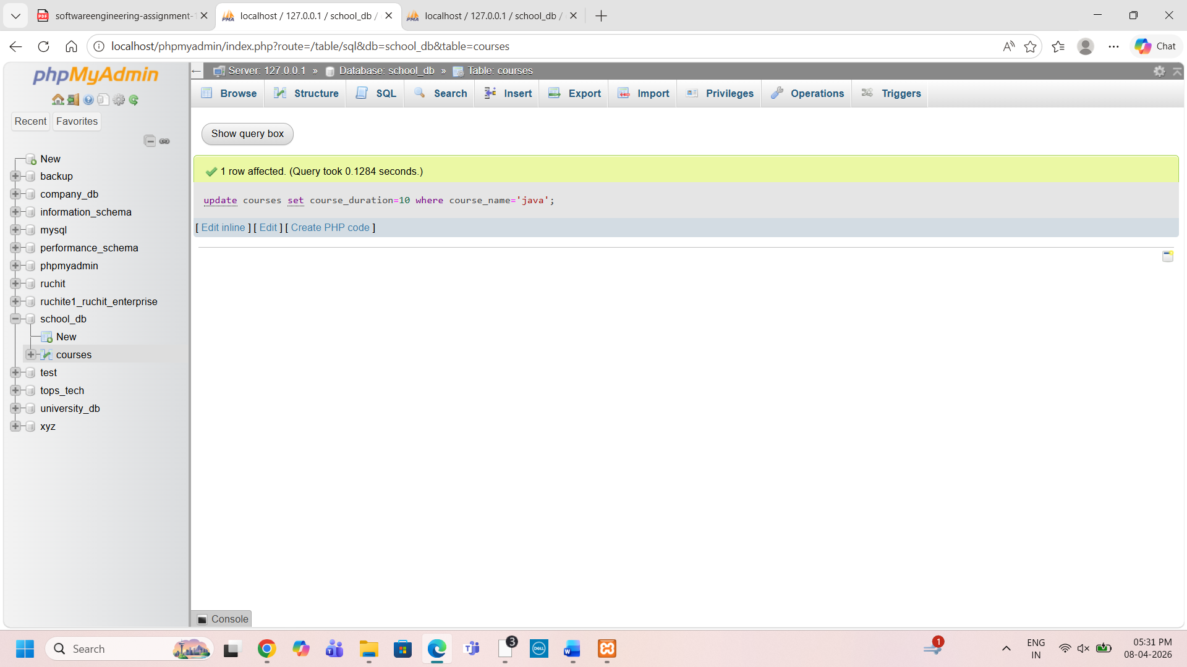
7.3) Delete a course with a specific course_id from the courses table using the DELETE command.
delete from courses where course_id=1
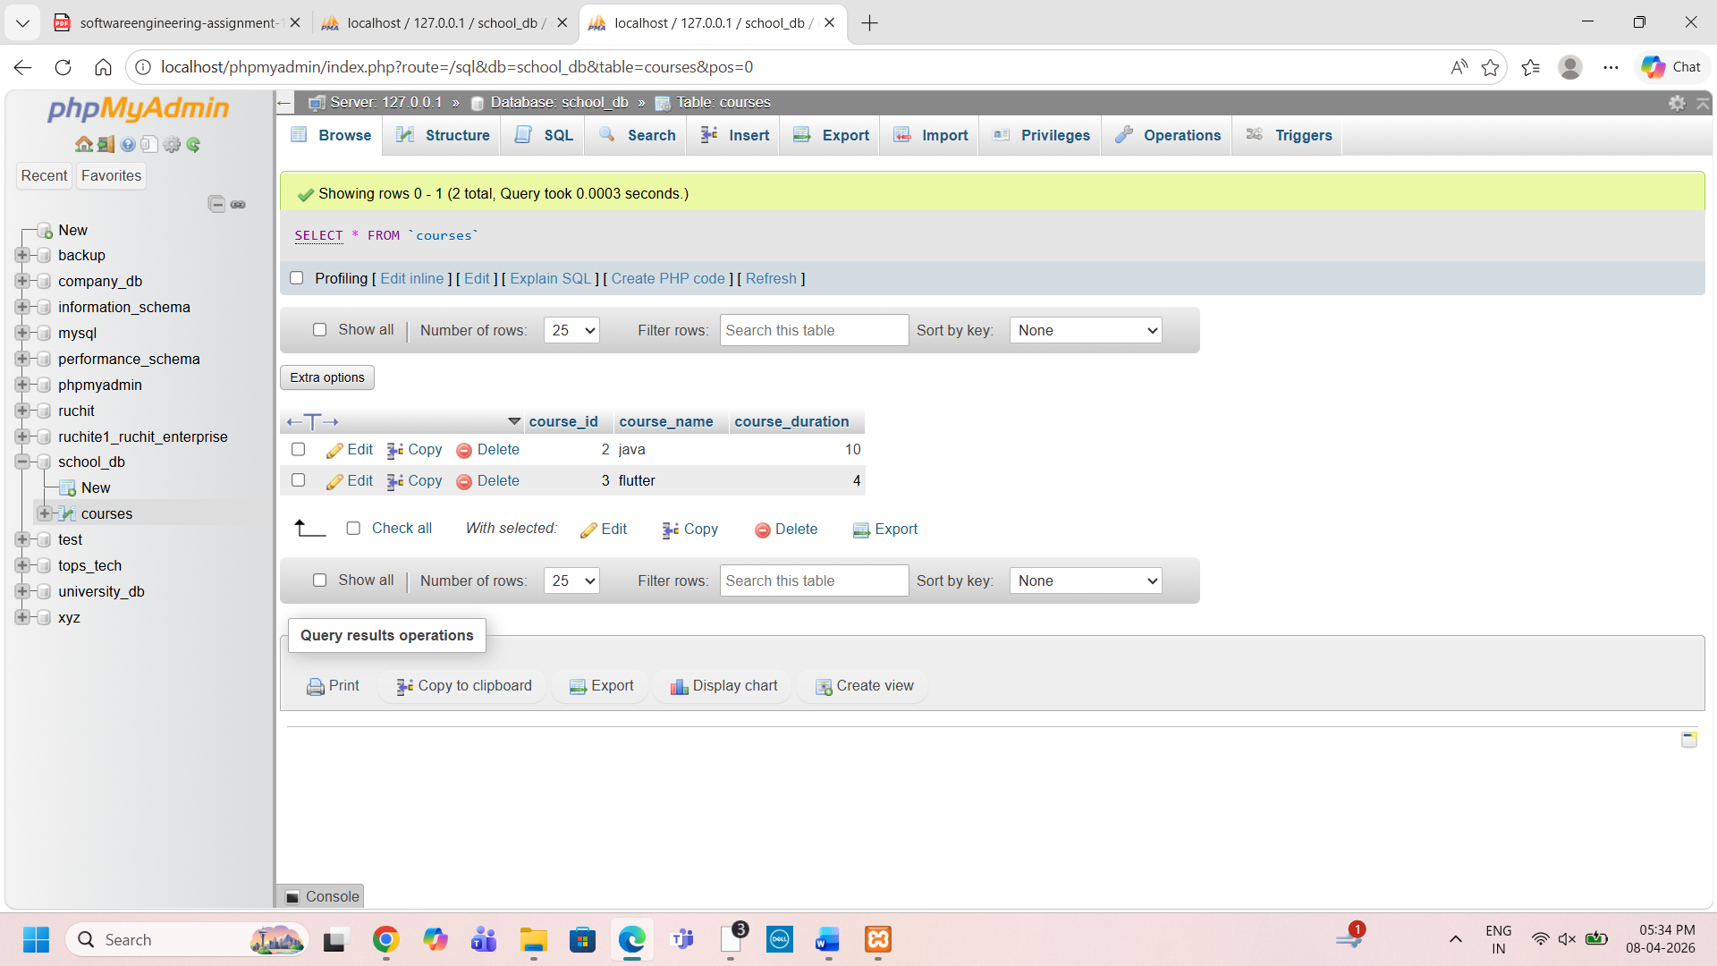
8.1)Retrieve all courses from the courses table using theSELECT statement.
SELECT * FROM `courses`;
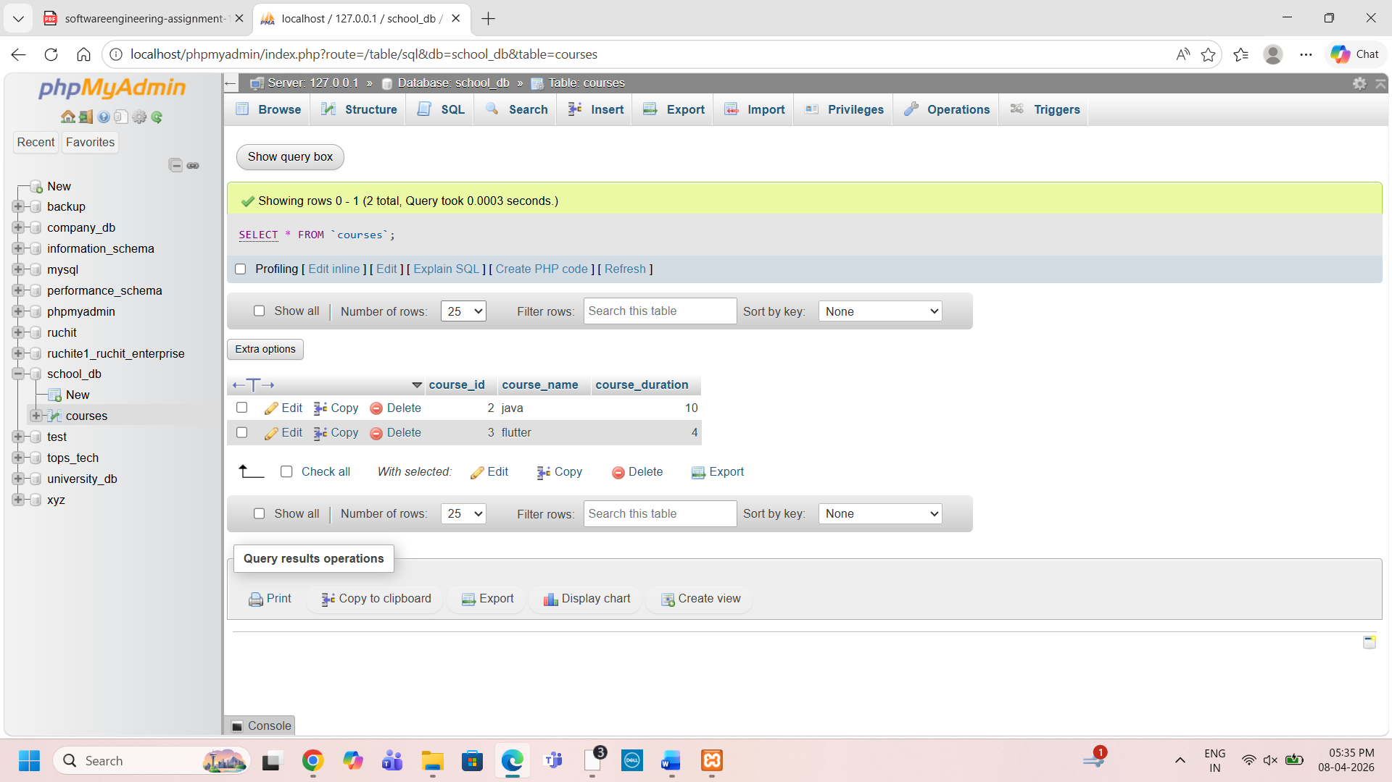
8.2)Sort the courses based on course_duration in descending order using ORDER BY.
SELECT * from courses order by course_duration desc;
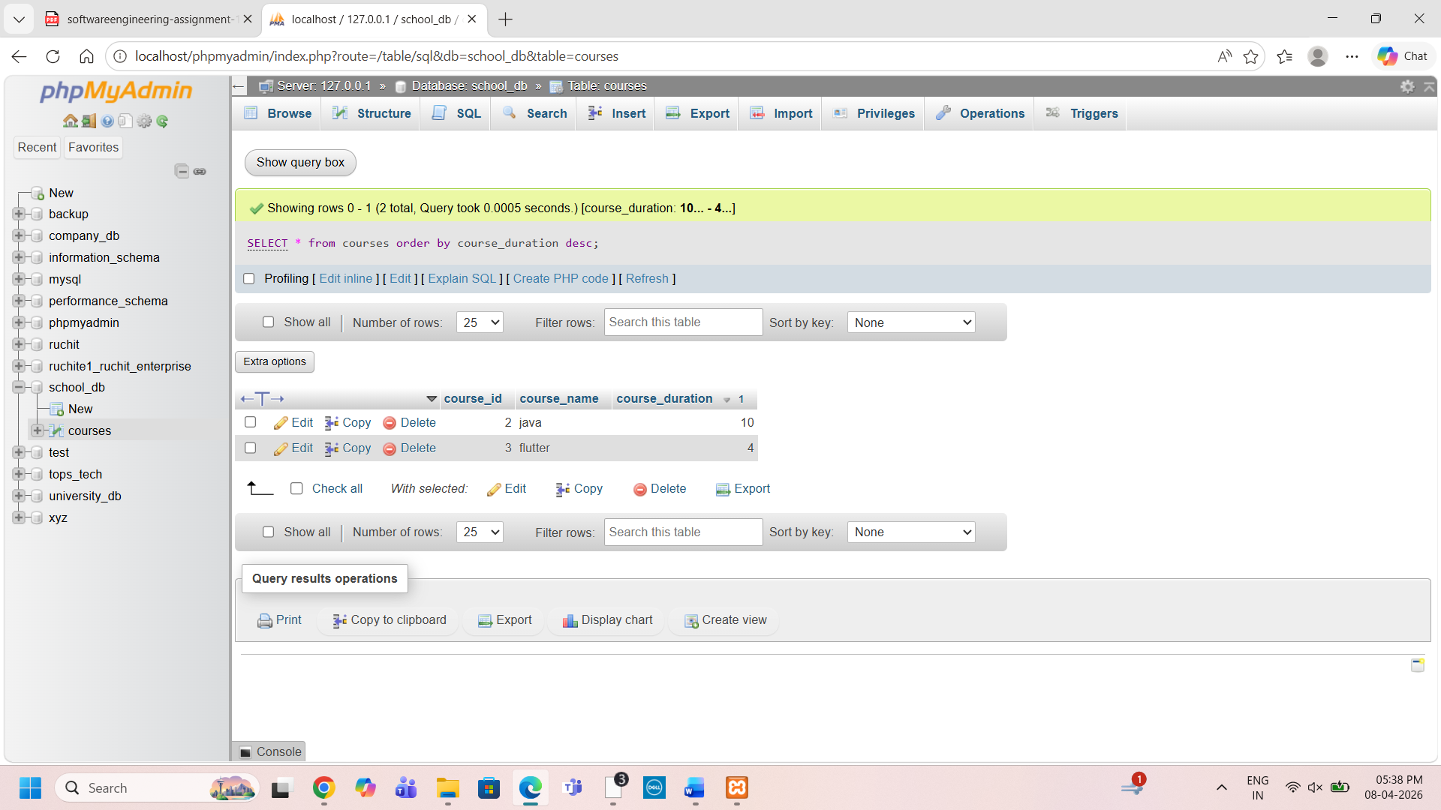
8.3)Limit the results of the SELECT query to show only the top two courses using LIMIT
select * from courses LIMIT 2;
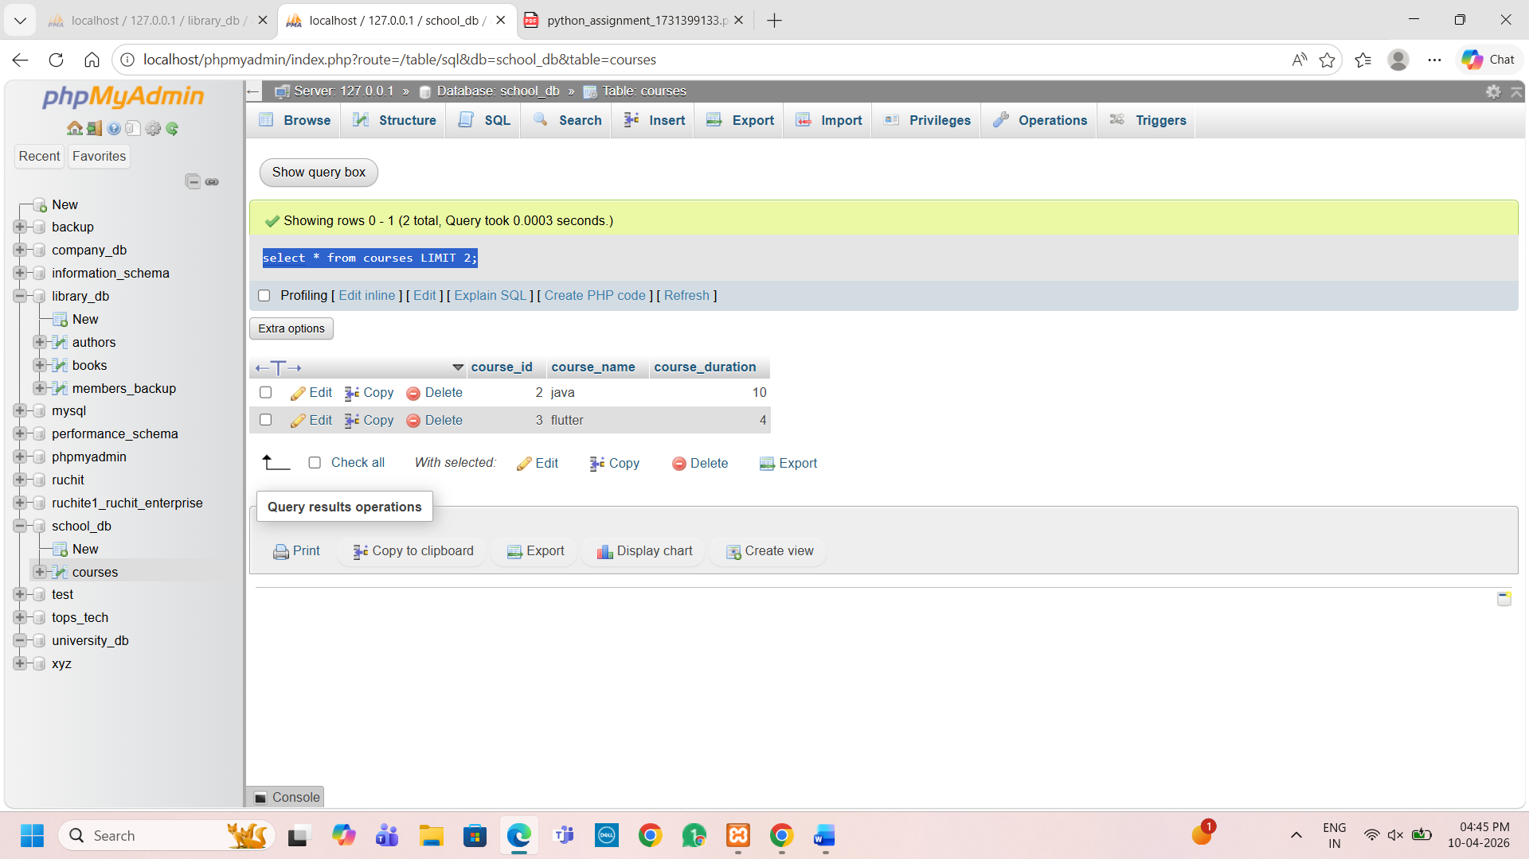
9.1) Create two new users user1 and user2 and grant user1 permission to SELECT from the courses table.

